
4
August 2026 Contract Schools 6-2-26
Monday | Tuesday | Wednesday | Thursday | Friday | 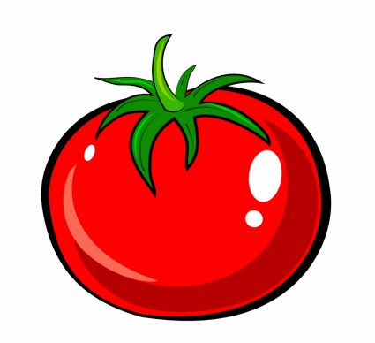  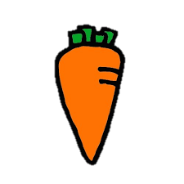  Every week, an  additional ¼  cup of veggies is offered to meet the USDA Federal guidelines for ¾ cup red/orange vegetable subgroup. This alternates weekly between baby carrots and grape tomatoes.  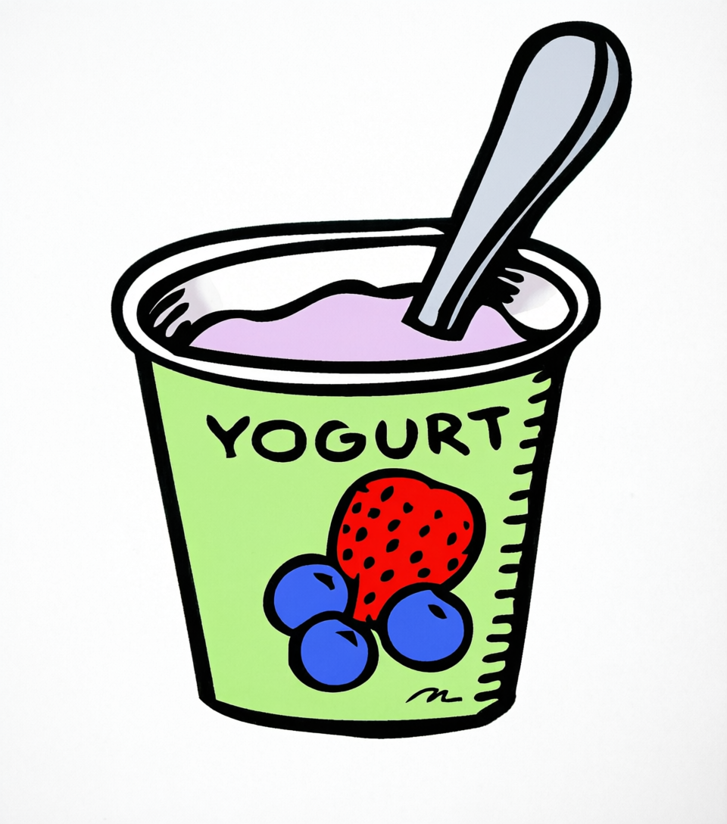  In addition to  the daily hot  entree and cold alternative, a third option is available.  - Yogurt w/a Cheese Stick OR Sunflower Seeds, & Assorted Bread  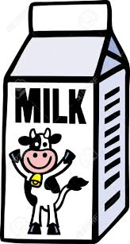  8 oz. nonfat  unflavored,  nonfat flavored, or 1% unflavored milk served daily.  Please visit https://westsidecommunityschoolsne.mealviewer.net/#home for the most up-to-date menus. Menus subject to change.   Denotes PORK in the product.  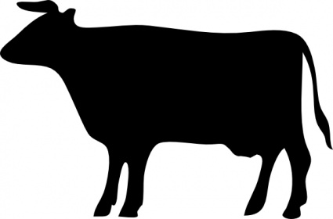 Denotes BEEF in the product  Vecteezy.com
3  Crispy Chicken Sandwich  Crinkle Fries  Applesauce   | 4  Breaded Mozzarella Cheese Sticks with Pizza Sauce  Baby or Steamed Carrots  Mandarin Oranges | 5  Pizza Hut Pizza  Fresh Broccoli  Strawberries | 6  Walking Tacos  Shredded Lettuce &  Cheese  Black Beans  Watermelon | 7  Popcorn Chicken  Assorted Bread  Green Beans  Peaches
10  WG Pancakes with  Chicken Sausage  Breakfast Yams  Craisins | 11  Chicken Soft Taco  Mixed Vegetables  Orange Smiles | 12  Pizza Hut Pizza  Romaine Salad with  Croutons  Banana | 13  Corn Dog (chicken)  Or - Asian Chicken Wrap  Baked Beans  Cantaloupe Farm to School  Ice Cream Cup | 14  Cheeseburger  Or - Turkey & Cheese  Hoagie  Crinkle French Fries  Cinnamon Applesauce
17  Popcorn Chicken with  Assorted Bread  Or- Sunbutter & Jelly  Sandwich w/a Cheese  Stick  Green Beans  Mixed Fruit | 18  BBQ Roasted Chicken  Drumstick  Farm to School with a Soft Pretzel  Or - Ham & Cheese Hoagie  Golden Corn  Chilled Peaches | 19  Pizza Hut Pizza  Or - Tuna Salad on 9  Grain Bread  Romaine Salad with  Croutons  Craisins | 20  Crispy Beef Tacos with  Lettuce & Cheese  Or – Southwest Chicken Wrap  Seasoned Black Beans  Watermelon Farm to School | 21  Colby Cheese Omelet  with a Biscuit  Or - Turkey & Cheese  Hoagie  Steamed Carrots  Orange Smiles
24  Chicken Fried Steak  Sandwich  Or- Sunbutter & Jelly  Sandwich w/a Cheese  Stick  Fresh Broccoli  Chilled Pears | 25  Herbed Chicken over  Bow Tie Pasta with  Assorted Bread  Or - Italian  Hoagie  Iceberg Salad  Banana | 26  Cheesy Nachos  Or - Chicken Salad on  9 Grain Bread  Chili Beans  Crisp Apple  Fruit Roll-up Treat | 27  Big Ol’ Meatball with  Garlic Bread  Or - Chicken Bacon Ranch Wrap  Garden Peas  Cantaloupe Farm to School | 28  Breaded Mozzarella  Cheese Sticks with  Pizza Sauce  Or - Turkey & Cheese  Hoagie  Sweet Potato Fries  Fruit Slushy
This Institution is an equal opportunity provider.

